Analysis of Wealth Distribution Among the 500 Richest Individuals
MSDS670 – Data Visualization
Maryi Tatiana Palacios Giraldo
Regis University
March 2026

Introduction

Wealth inequality and the concentration of financial resources among a small number of individuals have become increasingly important topics in economic and social discussions. Understanding how wealth is distributed among the richest individuals in the world can provide insights into economic structures, industry influence, and geographic patterns of wealth creation.

This project analyzes a dataset of the 500 richest individuals in the world. The goal is to explore the distribution of net worth, identify the industries that generate the most extreme wealth, and examine which countries have the highest concentration of billionaires. Through data visualization and analysis, this project highlights key patterns in global wealth distribution.

Problem/situation
The distribution of extreme wealth has become an important topic in discussions about the global economy and economic inequality. Understanding how wealth is concentrated among the richest individuals can provide insights into which industries and countries generate the largest fortunes. However, it is often difficult to clearly see these patterns without analyzing and visualizing the data.
This project examines a dataset of the 500 richest individuals in the world in order to better understand how wealth is distributed and what economic factors are associated with extreme levels of wealth.

Research Question
What patterns can be identified in the distribution of wealth among the 500 richest individuals, and how are these patterns related to industry and geographic location?

Data
Data Description
The data set used in this analysis contains information about the 500 richest individuals worldwide. Key variables include:
- Net Worth – The total estimated wealth of everyone, measured in billions of U.S. dollars.
- Country – The country associated with the individual.
- Industry – The primary industry from which the individual’s wealth is derived.
- Year-to-Date Change and Daily Change – Measures of short-term changes in net worth.
These variables allow us to analyze not only the distribution of wealth but also the industries and geographic regions that contribute most to the accumulation of extreme wealth.

Methodology
This project uses exploratory data analysis to examine patterns in the dataset of the 500 richest individuals. The dataset includes variables such as net worth, country, industry, and changes in wealth.
Several data visualizations were created to better understand the data. A histogram was used to analyze the distribution of net worth, a bar chart was used to identify the most common industries among the richest individuals, and another bar chart was used to compare the countries with the highest number of billionaires. These visualizations allow for clearer interpretation of patterns in wealth concentration, industry influence, and geographic distribution.

Results
Visualization 1 – Distribution of Net Worth
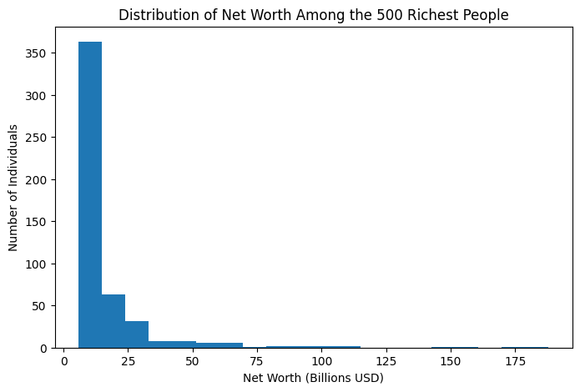
The first visualization examines the distribution of net worth among the 500 richest individuals.
The results show a highly right-skewed distribution, where most individuals have relatively lower net worth compared to a very small group at the top. A large proportion of individuals have a net worth below $25 billion, while only a few exceed $100 billion. This pattern indicates that even among the wealthiest individuals, extreme wealth is concentrated in a very small number of people.
This distribution reflects the nature of wealth accumulation, where economic advantages, ownership of scalable businesses, and investment growth allow a small group to reach significantly higher wealth levels than the rest of the population.

Visualization 2 – Industries of the Wealthiest Individuals

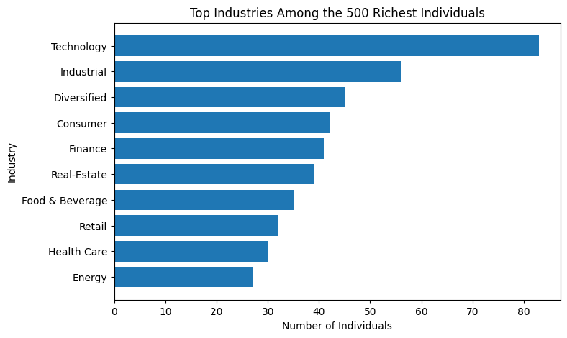
The second visualization focuses on the industries that appear most frequently among the richest individuals.
The analysis shows that the technology sector dominates, containing the largest number of individuals in the dataset. This highlights the significant role that digital innovation, software platforms, and global technology companies play in generating extreme wealth. Technology companies often benefit from scalability and global markets, which can lead to rapid increases in company value.
Other important industries include industrial, consumer, diversified, and finance sectors. While these sectors are more traditional, they continue to produce large fortunes through manufacturing, investments, and global business operations.
Overall, the results suggest that both high-growth industries and established sectors contribute to the creation of extreme wealth.

Visualization 3 – Countries with the Most Billionaires

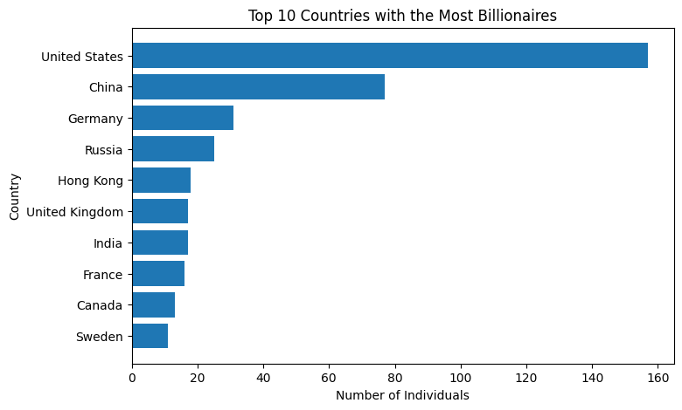

The third visualization examines the countries with the largest number of billionaires.
The United States has the highest number of individuals among the 500 richest people, far surpassing other countries. This reflects the country’s strong financial markets, large economy, and well-developed entrepreneurial ecosystem.
China ranks second, demonstrating the rapid growth of its economy over the past several decades. The rise of Chinese billionaires is closely tied to industrial expansion, technology companies, and domestic market growth.
Several European countries, including Germany, the United Kingdom, and France, also appear among the top countries. This indicates that established economies with strong industrial and financial sectors continue to generate significant wealth.

Conclusions
Overall, the analysis highlights several important patterns in the distribution of extreme wealth among the 500 richest individuals in the world. First, the distribution of net worth is highly unequal, even within this elite group. Most individuals have a net worth below $25 billion, while only a very small number exceeds $100 billion. This demonstrates that wealth is extremely concentrated at the very top.

Second, the results show that the technology sector plays a major role in the creation of modern wealth. Many of the richest individuals built their fortunes through technology companies and digital platforms. The scalability and global reach of technology businesses allow for rapid growth and significant value creation. At the same time, traditional industries such as finance, industrials, and consumer sectors continue to contribute to the accumulation of large fortunes.

Finally, the geographic distribution of billionaires shows that wealth is concentrated in a few major economic centers. The United States leads by a wide margin, reflecting its strong entrepreneurial environment, capital markets, and innovation ecosystem. China follows in second place, highlighting its rapid economic development over recent decades. European countries also maintain a significant presence due to their long-established industries and economic stability.

